Moving Main Menu Items Up or Down
Example – Move “Search” menu above “Photos”

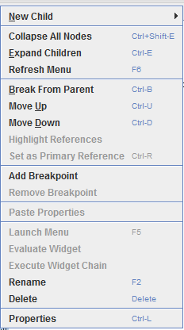
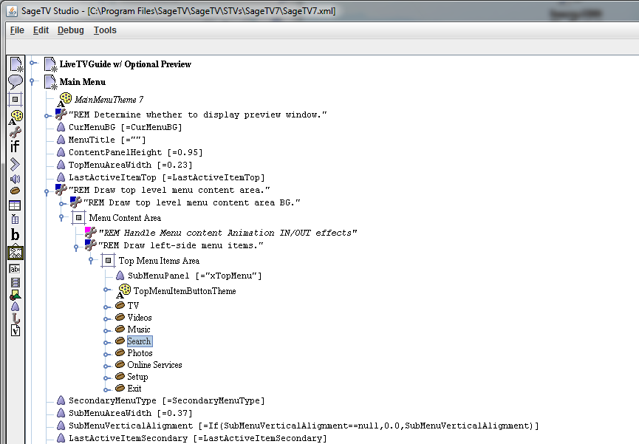
- Navigate Tree to find “Main Menu” to selected item; right-click to bring up edit menu and move item.
- Save changes in Studio and refresh the menu (F6) to see changes in the GUI.

Results

Before (default) After
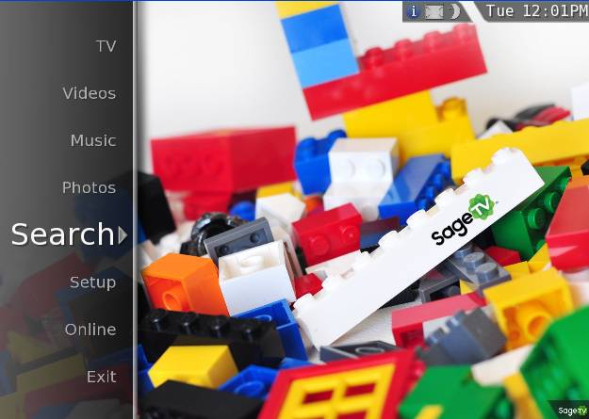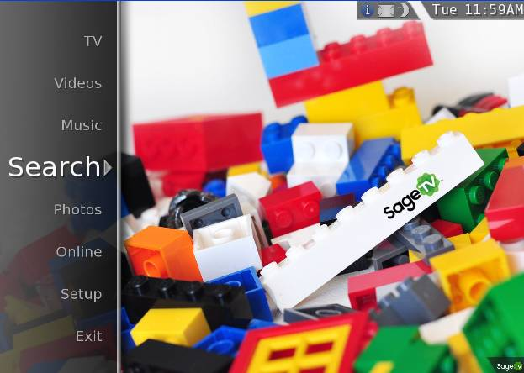

Moving “Inside” Menu Items Up or Down
Example – Move Secondary Menu item “Live TV” to bottom of the TV Menu list

- Find out the Secondary Menu name to apply change - For “TV”, submenu is “xSubmenuTV”
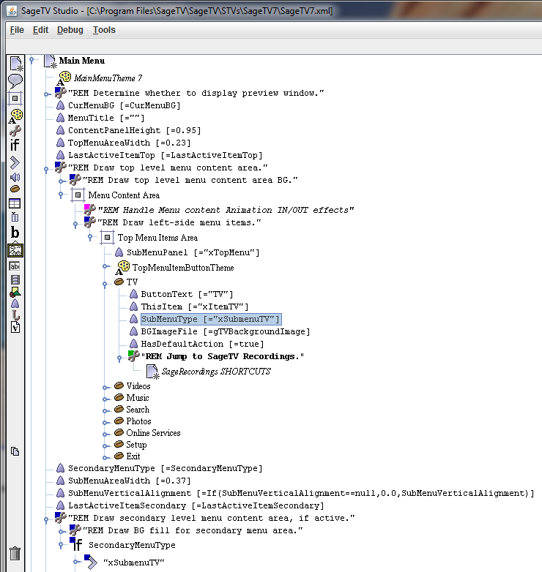
- Note the name of the submenu is “xSubmenuTV”
- Submenus will be found under the “REM Draw secondary level menu” within the Main Menu tree structure.

- Find “Live TV” menu item and move down using the edit menu
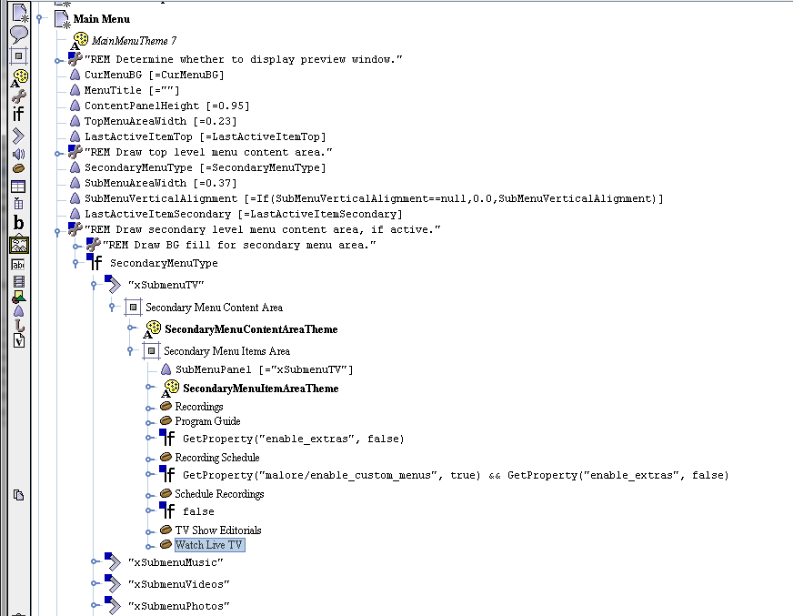
- Locate “xSubmenuTV” within Main Menu tree structure; right-click to bring up edit menu and move item.
- Save changes in Studio and refresh the menu (F6) to see changes in the GUI.

Results

Before (default) After
