Setup of DLNA OTA Tuners
1. Setup the tuner as you normally would with your lineup ... If you already have a legacy non DLNA OTA Tuner setup copy the lineup as the mappings will be different.

2. Once tuner is setp with line up do not do a scan ... Instead go to channel setup here is will you will remap the physical channel. Bring up your HD Homerun setup software locate your tuner do a scan if necessary. Take note of the Guide Number column that is the numer your physical channels will be mapped to.
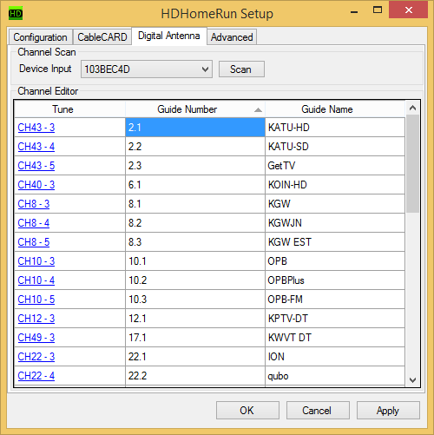
3. Start remapping ... Click on Remap Channel the highlight remap channel You will notice to the right it says Physican Chan. .... this is where you will remap. Click on it and input the number exactly as it appears in the HD Homerun setup software.
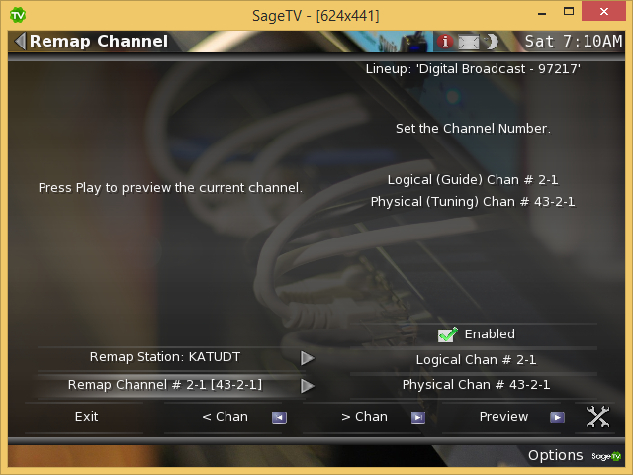
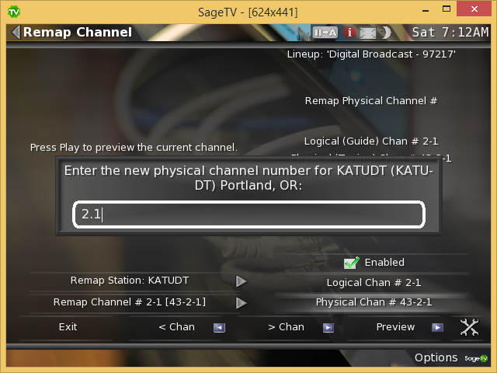

Continue until all channels re-remapped. The last step is to disable any channels the HD Homerun scan did not find.

