How to set CyberLink Codec settings for SageTV.
- Download Radfilter from the web.
For example: http://www.videohelp.com/tools/RadLight_Filter_Manager
- In sage go to : setup > detailed setup video/audio and set as below.
In my setup mpeg2 and H.264 files are played by Cyberlink codec and rest will be played by default DirectShow codecs setting. You can use graphedit tool to see which codecs are used when default settings are applied. The tool can be downloaded from:
http://www.videohelp.com/tools/GraphEdit

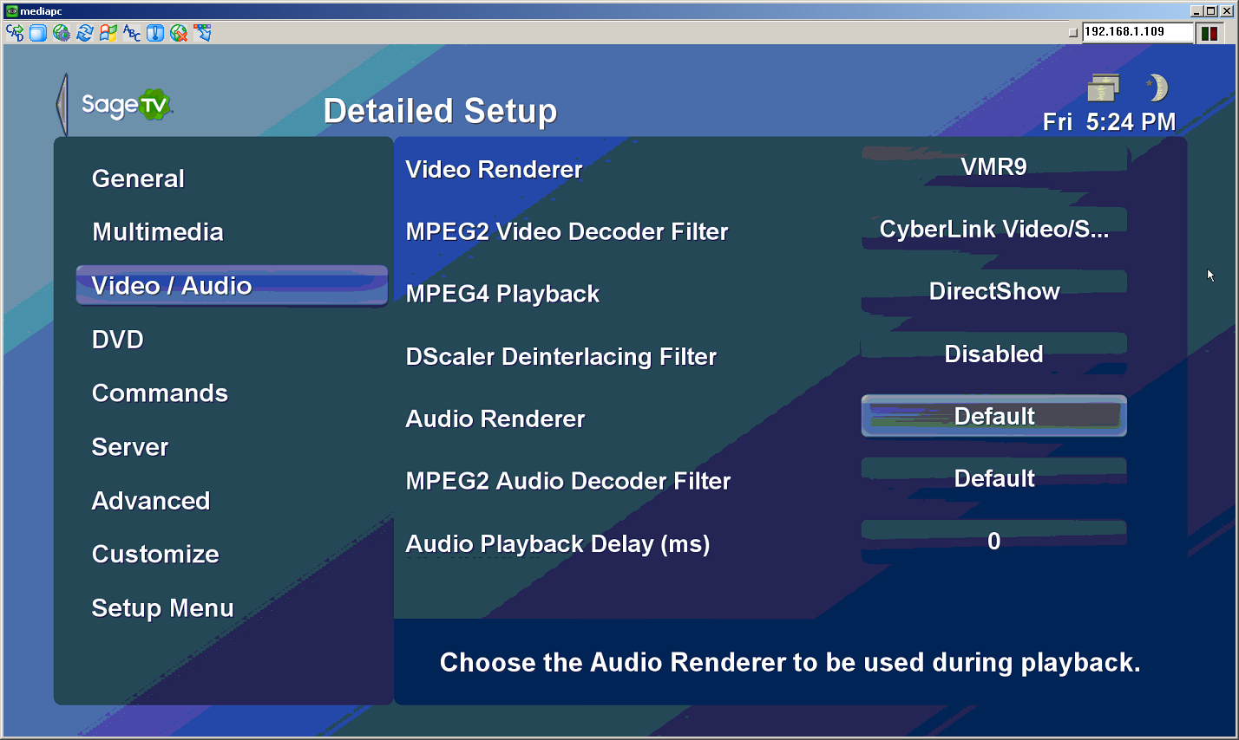
- In sage.properties file set:
always_use_dshow_player=true
videoframe/h264_video_decoder_filter=CyberLink H.264/AVC Decoder (PDVD7.x)
Make sure that “CyberLink H.264/AVC Decoder (PDVD7.x)” matches the name of the cyberlink codec in your system. It will allow you to use hardware acceleration while playing v.264 files. You can check the name by looking at the directshow filters using the filter manager.
- Start the filtermanager and click the plus sign next to Directshow filters and find the cyberlink filter that you want to set setting for.
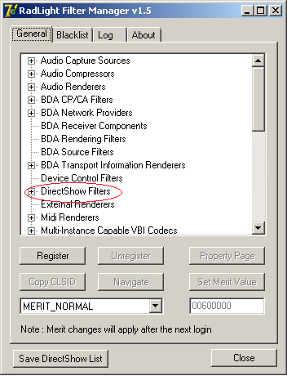
- Click Properties and set to your needs.
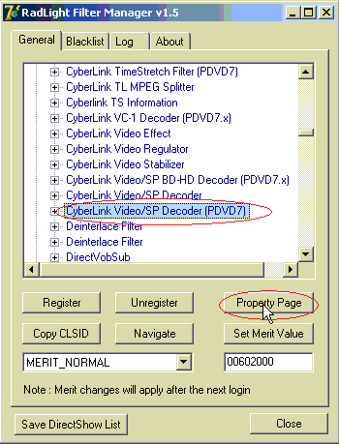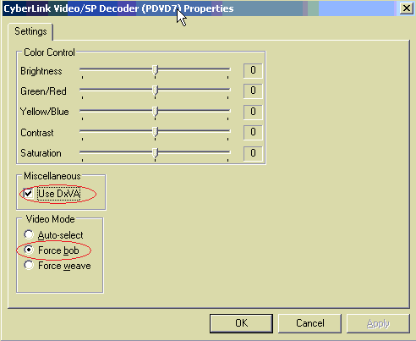
- Click ok and close all windows.
- Now open registry editor (regedit.exe) and go to:
Hkey_Current_user\Software\cyberlink\common
The keys of interest are: CLAud and CLVSD.
The example here is for video settings only, but same procedure applies to audio settings.
Click CLVSD and you will notice the new key created by filter manager. It includes all your custom codec settings.
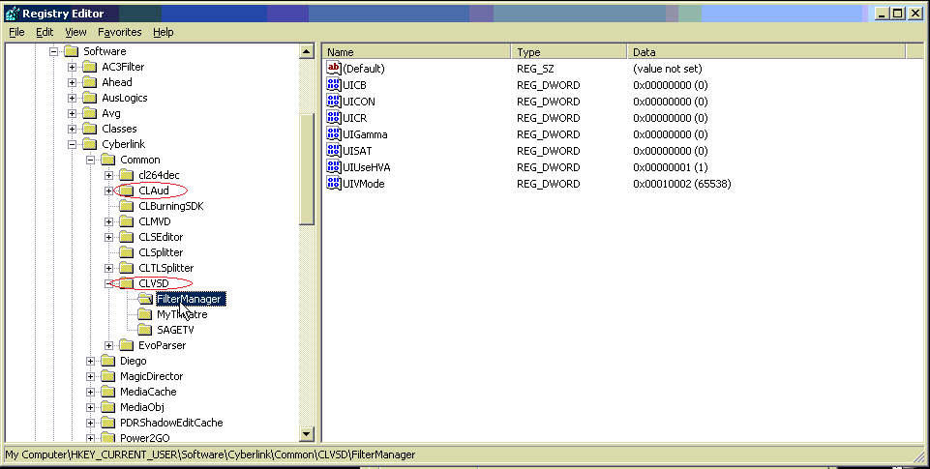
Right click the Filtermanager key and click export. Save the file to the desktop.
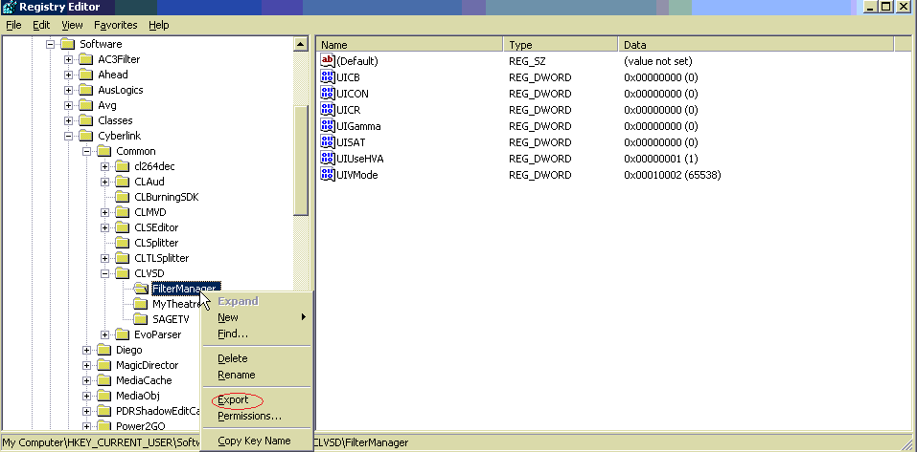
- Edit the saved file and replace Filtermanager with Sagetv and save.
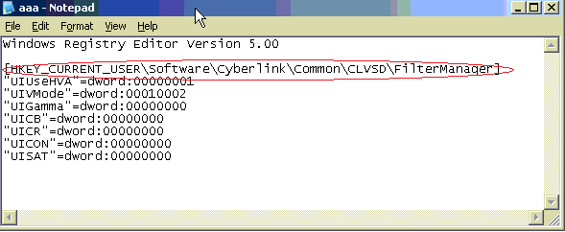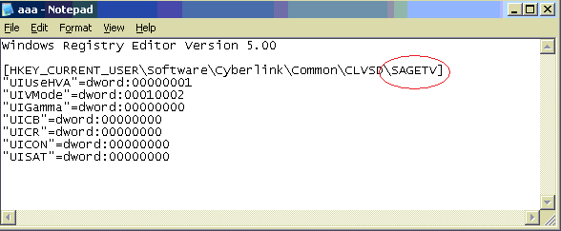
- Double click the saved file to import new sagetv codec setting for cyberlink.
- Play mpeg2 file to test.
- Use above procedure to set cyberlink codes for H264 codec or to set cyberlink audio codecs.

